THE KEVIN HERLIHY MEMORIAL TOURNAMENT
(MENS TOURNAMENT ONLY)
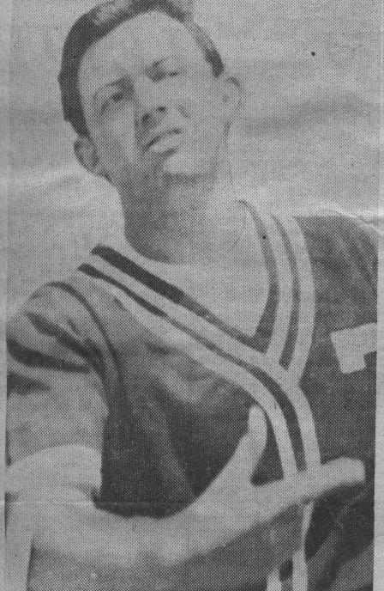
SUNDAY, 10 NOVEMBER 2012
TOM VOYLE PARK SPORTS CLUB
CAMBRIDGE
ENTRY FEE: $100.00
(LIMITED TO FIRST 8 ENTRIES)

1st Place ONLY
THERE CAN BE ONLY ONE!!

Win your Team Name on
The Kevin Herlihy Trophy
And $500.00 Prize Money
REGISTRATIONS CLOSE 31/10/12
Please return your interest to
helen.rogers@xtra.co.nz

REMEMBERING ONE OF THE GREATS
Kevin Herlihy was born & raised in Wellington and played for the province before moving to the Waikato in the 1970’s. He began his international softball career as a teenager with the NZ team in 1966 at the inaugural men’s world championships.

He remained on the mound dominating the best hitters in the world through to his retirement in 1984.Following his playing career Herlihy was a Selector with the NZ Men’s team during the early 1990’s, Pitching Coach with the Black Sox in 1996 and attended the 2000 Olympics with the White Sox..

NZ Softball Chief Executive Dale Eager described Herlihy as a true sporting legend and one of the faces of the sport recognised around the world. “In terms of pitching ability he was the best in the world and he was acknowledged as such by all those who played against him.

Kevin was inducted into the NZ Sports Hall of Fame in 1990 and the International Softball Congress Hall of Fame in 1991 and The Softball NZ Hall of Fame in 1995.

Kevin Herlihy was a legend, an untouched pitching master and a great competitor.

His name will live in New Zealand sporting history as “The Babe Ruth” of our game!

